DRY (Don't repeat yourself)
Our first object oriented design principle is DRY, as name suggest DRY (don't repeat yourself) means don't write duplicate code, instead use Abstraction to abstract common things in one place. If you have block of code in more than two place consider making it a separate method, or if you use a hard-coded value more than one time make them public final constant. Benefit of this Object oriented design principle is in maintenance. It's important not to abuse it, duplication is not for code, but for functionality . It means, if you used common code to validate OrderID and SSN it doesn’t mean they are same or they will remain same in future. By using common code for two different functionality or thing you closely couple them forever and when your OrderID changes its format , your SSN validation code will break. So beware of such coupling and just don’t combine anything which uses similar code but are not related.

Encapsulate What Changes
Only one thing is constant in software field and that is "Change", so encapsulate the code you expect or suspect to be changed in future. Benefit of this OOPS Design principle is that it is easy to test and maintain proper encapsulated code. If you are coding in Java then follow principle of making variable and methods private by default and increasing access step by step e.g. from private to protected and not public. Several of design patterns in Java uses Encapsulation, Factory design pattern is one example of Encapsulation which encapsulate object creation code and provides flexibility to introduce new product later with no impact on existing code.

Favor Composition over Inheritance
Always favor composition over inheritance ,if possible. Some of you may argue this, but I found that Composition is lot more flexible than Inheritance. Composition allows to change behavior of a class at run-time by setting property during run-time and by using Interfaces to compose a class we use polymorphism which provides flexibility of to replace with better implementation any time. Even Effective Java advise to favor composition over inheritance. See here to learn more about why you Composition is better than Inheritance for reusing code and functionality.

Programming for Interface not implementation
Always program for interface and not for implementation this will lead to flexible code which can work with any new implementation of interface. So use interface type on variables, return types of method or argument type of methods in Java. This has been advised by many Java programmer including in Effective Java and Head First design pattern book.

Delegation principle
Don't do all stuff by yourself, delegate it to respective class. Classical example of delegation design principle is equals() and hashCode() method in Java. In order to compare two object for equality we ask class itself to do comparison instead of Client class doing that check. Benefit of this design principle is no duplication of code and pretty easy to modify behavior.

5 class/interface design principles [S.O.L.I.D.] in java
Classes are the building blocks of your java application. If these blocks are not strong, your building (i.e. application) is going to face the tough time in future. This essentially means that not so well-written can lead to very difficult situations when the application scope goes up or application faces certain design issues either in production or maintenance.
On the other hand, set of well designed and written classes can speed up the coding process by leaps and bounds, while reducing the number of bugs in comparison.
These design principles are called SOLID, in short. They also form the best practices to be followed for designing your application classes.
- Single Responsibility Principle
- Open Closed Principle
- Liskov’s Substitution Principle
- Interface Segregation Principle
- Dependency Inversion Principle
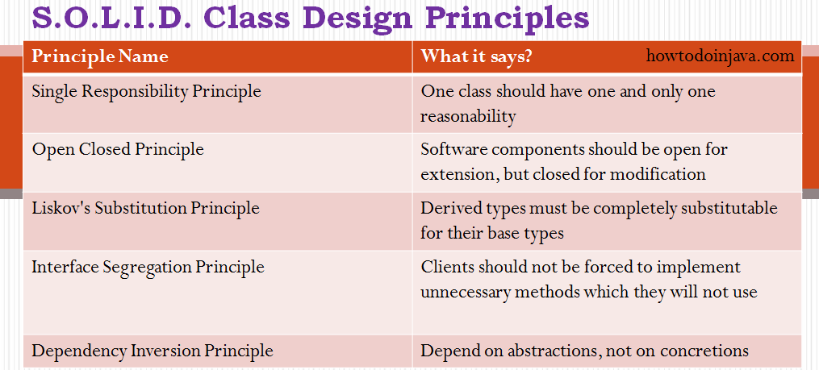
5 java class design principles
Lets drill down all of them one by one.

Single Responsibility Principle
The name of the principle says it all:
"One class should have one and only one responsibility"
In other words, you should write, change and maintain a class for only one purpose. If it is model class then it should strictly represent only one actor/ entity. This will give you the flexibility to make changes in future without worrying the impacts of changes for another entity.
Similarly, If you are writing service/manager class then it should contain only that part of method calls and nothing else. Not even utility global functions related to module. Better separate them in another globally accessible class file. This will help in maintaining the class for that particular purpose, and you can decide the visibility of class to specific module only.

Open Closed Principle
This is second important rule which you should keep in mind while designing your application. It says:
"Software components should be open for extension, but closed for modification"
What does it mean?? It means that your classes should be designed such a way that whenever fellow developers wants to change the flow of control in specific conditions in application, all they need to extend your class and override some functions and that’s it.
If other developers are not able to design desired behavior due to constraints put by your class, then you should reconsider changing your class. I do not mean here that anybody can change the whole logic of your class, but he/she should be able to override the options provided by software in unharmful way permitted by software.
For example, if you take a look into any good framework like struts or spring, you will see that you can change their core logic and request processing, BUT you modify the desired application flow just by extending some classes and plugin them in configuration files.

Liskov’s Substitution Principle
This principle is a variation of previously discussed open closed principle. It says:
"Derived types must be completely substitutable for their base types"

Ex:

Parent p = new Parent(); --> version1

Parent p = new Child(); --> version2

Now version 2 should not affect the parent behaviour at anytime.

Likov's Substitution Principle states that if a program module is using a Base class, then the reference to the Base class can be replaced with a Derived class without affecting the functionality of the program module.

We must make sure that the new derived classes just extend without replacing the functionality of old classes. Otherwise the new classes can produce undesired effects when they are used in existing program modules.

This principle is just an extension of the Open Close Principle and it means that we must make sure that new derived classes are extending the base classes without changing their behavior.

Ex Violation of liskov principle

1) Child class method throwing RunTimeException.

2) Parent class is Rectangle and Child class is Square.

Interface Segregation Principle
This principle is my favorite one. It is applicable to interfaces as single responsibility principle holds to classes. It says:
"Clients should not be forced to implement unnecessary methods which they will not use"
Take an example. Developer Alex created an interface “Reportable” and added two methods generateExcel() and generatedPdf(). Now client ‘A’ wants to use this interface but he intend to use reports only in PDF format and not in excel. Will he achieve the functionality easily.
NO. He will have to implement two methods, out of which one is extra burden put on him by designer of software. Either he will implement another method or leave it blank. So are not desired cases, right??
So what is the solution? Solution is to create two interfaces by breaking the existing one. They should be like PdfReportable and ExcelReportable. This will give the flexibility to user to use only required functionality only.

Dependency Inversion Principle (form of decoupling)
Most of us are already familiar with the words used in principle’s name. It says:
"Depend on abstractions, not on concretions"

Dependency inversion is a specific form of decoupling where you decouple the higher levels of your system from the lower levels by separating them into libraries and using interfaces. This allows you to replace lower level parts of your system without major rework.
For example, instead of the higher level parts of the system creates concrete instances of the lower level classes an IoC container can be used to decouple how objects are created.
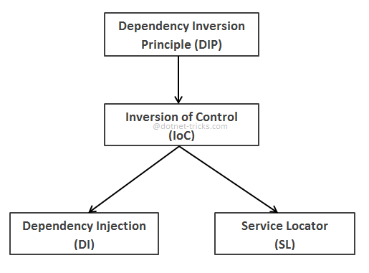
Dependence Injection or IOC is an important component of Dependency Inversion.

